8. Merger Model
All-cash, debt-funded, no shares issued. The deal is heavily EPS accretive — ~+60% in Year 1, ~+75% by Year 3 — because Sun adds a business almost its own size without diluting its share count, and Organon’s earnings yield far exceeds the after-tax cost of the acquisition debt. The accretion is real but leverage-driven: the headline EPS lift is financial engineering, so the deal must be judged on returns and the deleveraging path, not on EPS alone. Goodwill created ~$1.3bn; net leverage ~2.3x at close.

8.1 Sources & Uses ($mm)
Sources | $mm | Uses | $mm
New acquisition debt | 9,500 | Refinance Organon debt | 8,100
Sun internal accruals | 2,240 | Equity consideration | 3,640
Organon balance-sheet cash | 250 | Fees & expenses (est.) | 250
Total sources | 11,990 | Total uses | 11,990

8.2 Purchase price allocation
PPA ($mm) | Value
Equity purchase price | 3,640
less: Organon book equity (est.) | (700)
Allocable excess | 2,940
Identifiable intangible step-up | 2,000
Deferred tax liability on step-up (19%) | 380
Goodwill (plug) | 1,320
Incremental amortization, pre-tax (15-yr life) | 133
Incremental amortization, after-tax | 108
Goodwill is not amortized (no EPS impact). The step-up creates ~$108m of after-tax amortization drag per year — the only PPA item that hits accretion. Book equity and step-up are analyst estimates, flagged.

8.3 Debt schedule
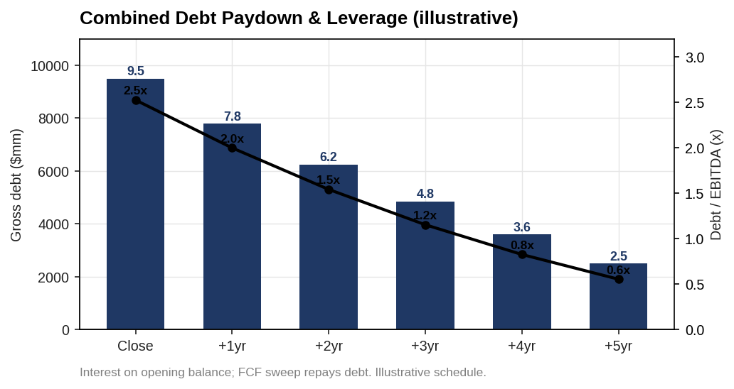
Combined debt paydown and leverage
Opening acquisition debt ~$9.5bn; interest computed on the opening balance (~$570m Year 1) to avoid circularity; a flat ~$1.8bn/yr FCF sweep repays principal. Net leverage starts ~2.3x and falls steadily on Organon’s cash flow. The paydown pace shown is illustrative (flat sweep); the point is directional — the combined entity deleverages quickly if Organon’s FCF holds.

8.4 Accretion / dilution
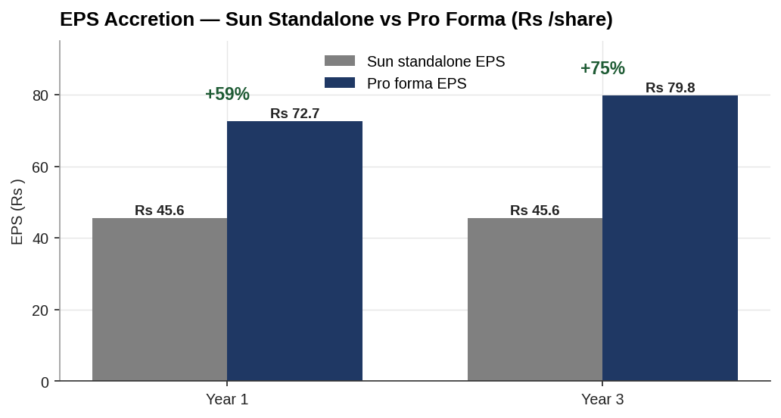
EPS accretion — standalone vs pro forma
Accretion ($mm unless noted) | Year 1 | Year 2 | Year 3
Sun standalone net income | 1,278 | 1,278 | 1,278
Organon pre-financing earnings (after-tax) | 1,319 | 1,319 | 1,319
less: new acquisition interest (after-tax) | (462) | (462) | (462)
less: forgone interest on cash (after-tax) | (73) | (73) | (73)
less: incremental PPA amortization (after-tax) | (108) | (108) | (108)
add: synergies (after-tax) | 85 | 198 | 283
Pro forma net income | 2,039 | 2,152 | 2,237
Sun standalone EPS (₹) | 45.5 | 45.5 | 45.5
Pro forma EPS (₹) | 72.7 | 76.7 | 79.7
Accretion / (dilution) % | +59.5% | +68.4% | +75.1%
New interest is held at the opening $9.5bn balance (conservative — no credit for deleveraging). Synergies phase 30% / 70% / 100%. No new Sun shares issued, so the full earnings pickup flows to EPS.
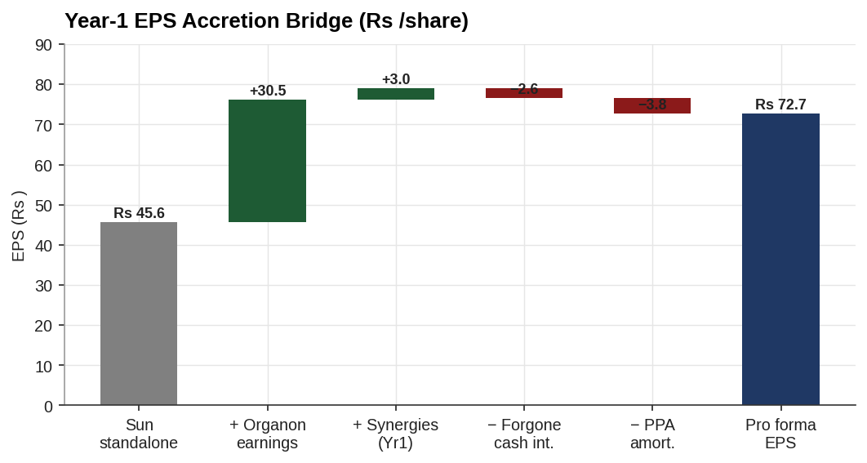
Year-1 EPS accretion bridge
The bridge shows the mechanics: Organon’s ~₹30.5/share earnings pickup dwarfs the ~₹6.4/share combined drag from acquisition interest and PPA amortization, with synergies (~₹3.0) on top.

8.5 Why the accretion is so large — and what it hides
The +60% headline follows mechanically from three facts: (1) all-cash, so no new shares dilute the denominator; (2) Organon adds ~$1.3bn of pre-financing after-tax earnings against Sun’s ~$1.3bn — nearly doubling the business; (3) Organon’s earnings yield (EBIT ÷ EV ≈ 13–14%) far exceeds the ~4.9% after-tax cost of the debt used to buy it. Any all-cash, debt-funded acquisition of a high-earnings-yield target at a low multiple is strongly accretive.
That is exactly why EPS accretion is the wrong scorecard here. The lift is bought with ~$9.5bn of debt; the same leverage that inflates EPS also concentrates risk. The correct tests — run in the risk chapter — are whether Organon’s FCF services and retires that debt, and whether returns exceed Sun’s cost of capital. EPS says yes loudly; the balance sheet says proceed carefully.

8.6 Merger conclusion
The transaction is materially EPS accretive from Year 1 (~+60%), rising to ~+75% by Year 3 as synergies phase in — with ~$1.3bn of goodwill and ~2.3x opening leverage that deleverages on Organon’s cash flow. Accretion is not the binding constraint; the binding constraints are Organon’s FCF durability (established-brands decline, the Nexplanon overhang) and refinancing the bridge. Those are stress-tested next.

Assumptions & sources
- Sun standalone: net income $1,278m (₹10,929cr ÷ FX 85.5), 2,399.3m shares, EPS ₹45.5. Held flat across years (conservative).
- Organon: adj. net income $954m; existing pre-tax interest ~$450m added back to derive pre-financing earnings; EBITDA $1,910m.
- Financing: new debt $9,500m at 6.0% blended; $2,240m Sun cash used at 4.0% forgone; tax 19%.
- Synergies: $350m run-rate, phased 30/70/100 (Ch.4); after-tax.
- PPA: equity purchase $3,640m, book equity $700m (est.), intangible step-up $2,000m over 15 yrs, DTL at 19%; goodwill is the plug.
- Debt schedule: interest on opening balance; flat $1,800m/yr FCF sweep — illustrative deleveraging, not a forecast.
- FX ₹85.5/USD; cross-border — INR acquirer, USD target.
Live model: Chapter 8 - Merger Model/Merger_Model.xlsx (Sources & Uses, PPA, Debt Schedule, Accretion — all formula-linked). Sources: prior chapters and company disclosures; full map in 05_Data/DATA_SOURCES.docx.

